Introduction

Hydraulics is based on a very simple fact of nature – you cannot compress a liquid .You can compress a gas(think about putting more and more air into a tire ,then more you put in, higher the pressure). If you’re really strong you can compress a solid mass as well. But no matter how much pressure you apply to a liquid into a sealed system and push on it at one end, that pressure is transmitted through the liquid to the other end of the system. The pressure is not diminished.

It is a system where liquid under pressure is used to transmit this energy. Hydraulic systems take engine power and convert it to Hydraulic power by means of the Hydraulic pump. This power can be distributed throughout the airplane by means of tubing that runs through the aircraft. Hydraulic power may be reconverted to mechanical power by means of the aircraft. Hydraulic power may be reconverted to mechanical power by means of an actuating cylinder, or turbine.

The various types of transmitting elements are employed to drive the mechanical links to a desired orientation. The various methods of drives are:

a. Hydraulic

b. Pneumatic

c. Electrical AC and DC Motors

The choice of the drive system s is based on the following factors:

1. Power consumption

2. Positional accuracy

3. Responsibility

4. Operational speed

5. Stability

6. Reliability

7. Cost and several related factors

Hydraulic system uses ‘oil’ under pressure and use electro-hydraulic valve. Hydraulic actuators can produce large force/torque to drive the manipulator joints without the use of reduction gearing.

Pneumatic system uses ‘air’ as the fluid medium with solenoid valve. These are difficult to control accurately due to high friction of seals and compressibility of air (or pneumatic medium). They are relatively cleaner than hydraulic systems.

Electric motors with electrical amplifiers and controllers and electrical stepper motor with suitable circuitry to control and interface. This is an added advantage of the electric systems but at the cost of increased joint friction, electric system but at the cost of increased joint friction, elasticity and backlash.

1.1 Fluid Power:

The term fluid power refers to the energy that is transmitted via a fluid under pressure. With ‘hydraulics’, that fluid is a liquid such oil or water; while in ‘pneumatic’, the fluid is typically compressed air or nitrogen gas (inert gas)

‘FLUID POWER TECHNOLOGY’ is a means to convert, transmit, control and apply fluid energy to perform useful work. Applications of fluid power include the following areas:

1. Agriculture

2. Aviation

3. Construction

4. Construction

5. Defense

6. Fabrication

7. Material Handling

8. Ships

1.2 FLUID

A fluid may be defined as a substance, which is capable of flowing, or a substance, which deforms continuously when subjected to external shearing force.

A fluid has the following characteristics:

* It has no definite shape of its own, but conforms to the shape of the containing vessel.
* Even a small amount of the shear force exerted on the fluids will cause it to undergo a deformation, which continuous as long as the force to be applied.

A fluid is classification as follows:

1. Liquid – It is a fluid, which possesses a definite volume, which varies only slightly with temperature and pressure. Liquids have bulk elastic modulus when compression and will store energy in the same manner as a solid. As the contraction of volume of a liquid under compression is extremely small, it is usually ignored and the liquid is assumed incompressible. A liquid will withstand a slight amount of tension due to molecular attraction between the particles, which will cause an apparent shear resistance, between two adjacent layers. This phenomenon is known as viscosity.
2. Gas – It possesses no definite volume and is compressible.
3. Vapour–It is gas whose temperature and pressure are such that it is very near the liquid state.

An ideal fluid is one, which has no viscosity and surface tension and is incompressible. In true sense, no such fluid exists in nature. However, fluids, which have low viscosities of ideal fluids, help in simplifying the mathematical analysis.

A real fluid is one, which has viscosity, surface tension and compressibility in addition to the density. The real fluid is available in nature.

Types of hydraulic fluids and selection criteria

There are innumerable types of materials in use as hydraulic fluids. These range from water to inorganic salt solutions to water oil emulsions, synthetic and naturally occurring organic materials.

Though water was the first hydraulic fluid and was used during the early stages of Industrial Revolution, petroleum based hydrocarbon type fluids are widely used today. Nevertheless, specific requirement of the hydraulic fluid is determined by the design of the system and by the function of the system is designed to perform. Certain characteristics are considered desirable in a good hydraulic fluid.

1.3 Hydraulic fluid Properties

1.3.1 Good Lubricity

The components of hydraulic system contain main surfaces which move in relation with each other. The Hydraulic fluid must separate and lubricate surfaces. Protection against wear is principle reason for selecting good lubricating characteristics as a hydraulic medium.

1.3.2 Stable Chemically and Physically

Fluid characteristics should be remain unchanged during an extended useful life and during storage. The fluid in the working hydraulic system is subjected to violent use large pressure fluctuations, shock, turbulence, aeration, cavitations, water and particulate contamination, high shear rates, and larger temperatures variations. Since many aspects of stability are chemical in nature, the temperature to which the fluid will be exposed is an important criterion in the selection of the hydraulic fluid.

1.3.3 Mass Density:

The density (specific mass) of a liquid may be defines as the mass per unit volume (m/V)at a standard temperature and pressure. It is usually denoted by (rho). Its units are kg/.

Mass density ‘’ = (mass’m’) / (volume’V’)

1.3.4 Weight Density:

The weight den weight) is defined as the weight per unit volume at the standard temperature and pressure. It is usually denoted by ‘w’.

Weight density ‘w’=*g

where,’g’ stands gravity.

For the purpose of all calculations, relating to hydraulics and hydraulic system, the specific weight of water is taken as

W=9.80665kN/ (SI units) =1000kg/

1.3.5 Specific Volume:

It is defined as volume per unit mass of the fluid denoted by’ υ’. Mathematically,

Specific volume ‘υ’= Volume’V’/ mass’m’

1.3.6 Viscosity

Viscosity is the most important property of the fluid. Viscosity of the fluid should be such as to yield optimum pump performance, due consideration being given to the type of pump, its operating speed and pressure. Use of fluid with too low viscosity increases leakage and may affect the life components because of inadequate lubrication, while that with too high a viscosity can cause inefficient operation due to the larger pressure drops and viscous drag with subsequent overheating. Pressure losses may be so high as to result in cavitations in pumps.

Viscosity changes with the temperature and pressure. The effect of the pressure on viscosity can be neglected in machine tool hydraulics. The effect of temperature on the fluid is indicated by its viscosity index. A fluid with higher viscosity index exhibits less change in viscosity for unit temperature change and is hence preferred.

1.3.7 Bulk Modulus/Compressibility

Bulk modulus which is the reciprocal of compressibility is defines as change in pressure required to cause unit volumetric strain. It is an important parameter in the system design, figuring surges due to sudden valves operations and drive stiffness resonance.

Two valves of bulk modulus –the isothermal and the isentropic –are admissible. Isothermal bulk modulus refers to the valve at content temperature. The isentropic bulk modulus is applicable when pressure changes are rapid allowing no time for entropy change and is referred to as the dynamic bulk modulus.

These valves are further defines as tangent and secant bulk modulus. The relation gives the isentropic tangent bulk modulus (Bst) at pressure ‘p’ and temperature ‘T’.

=-V

The isentropic bulk modulusat pressure ‘p’ and temperature ‘T’.

= (-dp/(dV/))s

Where dV=change in volume,

dp= change in pressure, = initial volume at atmospheric pressure. And subscript s is the constant entropy.

1.3.8 Resistance to Forming:

Hydraulic oil contains about 8% of dissolved air by volume. The dissolved air in Free State does considerably reduce the bulk modulus. The effect is less pronounced at high working pressure, since the free air tends to dissolve in oil at high pressures. One reduction of pressure, the dissolve in oil at high pressure. On reduction of pressure the dissolved air is released, promotion the formulation other bubbles, which may result in losses of the drive control as well possible breakdown of, pump due to cavitations. Antifoam agents are added to oils for increasing the rate of the bubbles.

1.3.9 Resistance to Oxidation:

Hydraulic fluids being composed of hydrocarbons tend oxidize. The rate of oxidation increased with the high operating temperature, ingress of water and metallic particles, which act as catalysts. The products of oxidation, which are acidic in nature, can be either soluble or insoluble in oil. Soluble oxidation products tend to thicken the oil while the insoluble ones generally known as sludge, may clog lines, orifices and filters. The oil rapidly degrades with the l breakdown. The extent of oxidation in a fluid milligram of potassium hydroxide needed to neutralize one gram of oil sample, the rate of increase of neutralization number is a good measure of the progress of oxidation. A neutralization number 1 is considered as the point for charging/ reconditioning of oil. Certain inhibitors added to the oil to improve resistance to oxidation.

FLUID FLOW:

Fluid flow is governed by a set of equations called Navier- Strokes equations and equations of Continuity; these are non –linear partial differential equations having complex boundary conditions and hence no general solutions. However for practical applications certain approximations have been made to reduce the complexities and make the solution accurate for most of the purposes. Calculations in hydraulics are generally based on:

1. Reynolds equations
2. Bernoulli’s equations for steady state flow.

The flow of the fluid in hydraulic system may be laminar, being physically characterized by orderly, smoothly, parallel line motion, or turbulent being irregular, erratic, eddy-like motion. The internal friction (viscous) forces dominate in laminar flow, whereas the inertia forces are predominated in turbulent flow is dependent on the dimensional number called Reynolds number being equal to

/

Laminar flow or turbulent flow can be either steady or unsteady depending on whether the velocities of fluid particles at a section are independent or dependent on time. Generally, the flow is assumed steady, incompressible and one-dimensional. In addition on fluid density and flow is negligible. Based on these assumptions, equations for flow pressure losses have been derived for different flow passages. For steady laminar flow, coefficient of loss (K) is multiplied by a correction factor ‘b’ which increases with the decreases in ‘Re’.

Laminable in systems to minimize the pressure losses, renders the system bulky. It prevails in leakage paths as well as in capillaries used for stabilization of valves, hydrostatic bearings and drives systems. A capillary is characterized by large-length to diameter ratio (1/d 400) of the passage. The capillaries are temperature sensitive and hence are unsuitable for control flow rates in hydraulic systems. Orifices associates with turbulent flow are commonly used for this purpose. An orifice is defined as an opening of short length causing sudden restriction in flow passage.

2 PRESSURE OF FLUID

When fluid is contained in a vessel, it exerts force at all points on the sides and bottom of the container. The force per unit area is ‘PRESSURE”.

If P= the force, and

A== area on which the forces act,

Then,

Intensity of Pressure ‘p’ = Force ‘p’/ Area ‘A’

The pressure of the fluid on the surface will always act normal to the surface. The intensity of the pressure of the fluid may be expressed in the following two ways:

1. As a force per unit area (i.e.,N/)

2. As an equivalent static head (i.e., meters, mm, cm of the liquid)

2.1 UNITS OF PRESSURE

The fundamental units SI unit of pressure is Newton per square meter N/ known as ‘Pascal’

2.2 ATMOSPHERIC PRESSURE

.The atmospheric air exerts a normal pressure upon all surfaces with which it is in contact and it is known as atmospheric pressure. The atmospheric pressure is also known as Barometric Pressure. The atmospheric pressure at a sea level (above absolute zero) is called standard atmospheric pressure.

2.3 GUAGE PRESSURE

It is pressure, measured with the help of pressure measuring instrument, in which the atmospheric pressure is taken as datum. The atmospheric pressure on the scale is marked as zero. “Gauge” record pressure above or below the local atmospheric pressure, since they measure the difference in presence in pressure above or below the local atmospheric pressure, since they and that of surrounding air. If the pressure of the liquid is below the local atmospheric pressure, then the gauge is designated as ‘vacuum gauge’ and the recorded valve indicated the amount by which the pressure of the liquid is below local atmospheric pressure i.e., negative pressure. (Vacuum pressure is defined as below the atmospheric pressure).

2.4 ABSOLUTE PRESSURE

It is necessary to establish an absolute scale, which is independent of the changes in atmospheric pressure. A pressure of absolute zero can exist only complete vacuum. Any pressure measured absolute zero pressure is termed as an ‘absolute pressure’.

Mathematically

1. Absolute pressure = Atmospheric pressure + Gauge pressure

2. Vacuum pressure= Atmospheric pressure- Absolute pressure.

3.BASIC LAWS

3.1 PASCAL ‘S LAW

It states that the intensity of pressure at any point in a liquid at rest is the same in all directions.

3.2 BERNOULI’S EQUATION

In an ideal incompressible fluid when the flow is steady and continuous, then sum of the pressure energy, potential energy and kinetic energy is constant along a stream line.

Mathematically, p/w+ /2g +Z =constant

Where, p/w = Pressure energy or head

/2g = Kinetic energy or head,

Z=Datum energy or head.

3.3 CONTINUITY EQUQTION

If no fluid is added or removed from the pipe in any length then the mass passing across different sections shall be same.

3.4 BOYLES’S LAW

It is stated that at constant temperature, the pressure (p) is inversely proportional to the volume (V) of a definite amount of gas (i.e., p 1/V or PV=constant)

Mathematically,

=

3.5 CHARLE’S LAW

It is stated that the volume (V) of a gas at constant pressure is directly proportional to the absolute temperature (T) (i.e.T or V/T = constant)

Mathematically,

=

Combined Universal Gas Equation is:

=

4. PRINCIPLE OF HYDRAULIC SYSTEM

Part of the hydraulic system is the actuating whose main function is to change hydraulic (fluid) power to mechanical (shaft) power. Inside the actuating cylinder is a piston whose motion is regulated by oil under pressure .The oil is in contact with both sides of the piston head but at different pressure. Higher pressure oil may be pumped into either sides of the piston head but at different pressure. High Pressure oil may be pumped into either side of the piston head.

The servo valve determines to which side of the actuating cylinder the high pressure oil is sent. The piston rod of the actuating cylinder is connected to the control surface.

As the piston moves out, the control surface moves down. As the piston moves in, the control surface moves up. The selector valve directs the higher pressure oil to the appropriate side of the piston head causing movement of the piston in the actuating cylinder, AS the piston moves, oil on the low pressure side returns to the reservoir since return lines have no pressure.

The differential in oil pressure causes movement of the piston. The force generated by this pressure difference can be sufficient to move the necessary loads. Each cylinder in the plane, boat, etc., is designed for what it must do. It can deliver the potential it was made for; no more, no less. Air loads generally determine the force needed in aircraft applications.

A hydraulic system transmits power by means of fluid flow under pressure. The rate of the oil through the system in to the actuating cylinder will determine the speed with which the piston rod in the actuating cylinder extends or retracts. When the cylinder is installed on the vehicle, it is already filled with oil. This ensures that no air bubbles are introduced into the hydraulic system, which can adversely affect the operation of the system.

The basic idea behind any hydraulic system is:”**Force that is applied at one point is transmitted to another point using an incompressible fluid**”. The high pressure –called hydraulic fluid –is transmitted through out the machine to various hydraulic motors and hydraulic cylinders. The fluid is controlled directly or automatically by control valve and distributes through hoses and tubes. Hydraulic fluid is the life of the /hydraulic system. For the hydraulic fluid to do work, it must flow to the actuator or the motor, then return to reservoir. The fluid is then filtered and re- pumped.

Is selected to have the following characteristics:

1. Good lubrication to prevent wear in moving components.

2. Corrosion résistance.

3. Incompressibility to provide rapid response.

Pascal’s theory:

In a confined stationary liquid neglecting the effect of gravity pressure is distributed equally and undiminished in all directions, it acts perpendicular to the surface it touches. Because the actuating cylinder is not vented, the force delivered through the piston to the surface of fluid is translated into a pressure on the surface of the fluid.

The pressure (p) acting on the incompressible oil does work [(pressure) x (area of piston) x (piston’s stroke) = work]

The path taken by hydraulic fluid is called a hydraulic circuit of which there are basic two types :

1. open center circuit
2. closed center circuit
3. Open center circuit:

It uses pumps, which supply a continuous flow. The flow is returned to tank through the control valves open center; that is, when the control valve is centered, it provides an open return path to tank and the fluid is not pumped to a high pressure. Otherwise, if the control valve is actuated it routes fluid to and from actuator and tank. The fluid pressure will rise to meet any resistance, since the pump has a constant output. If the pressure rises too high, fluid returns to tank through a pressure relief valve. This type of circuit can use inexpensive, constant displacement pumps.

1. Closed center circuit:

It supplies full pressure to the control valves, whether any valves are actuated or not. The pumps vary their flow rate, pumping very little hydraulic fluid until the operator actuates a valve. The valve’s spool therefore does not need an open center return path to tank. Multiple valves can be connected in a parallel arrangement and system pressure is equal for all valves.

4.1BASIC ELEMENTS OF AN OIL HYDRAULIC SYSTEM

1. Hydraulic Pump Unit:

* In an actual hydraulic system , a pump converts mechanical power into fluid power
* The intake of the pump is converted into a liquid source called a tank or reservoir.

1. Control Valves:

Valves control the flow of pressurized liquid discharges by the pump

* “Pressure control valves “control the liquid pressure.
* “Directional control valves “control the direction flow of the liquid.
* “Flow control valves” control the liquid flow rate.

1. Hydraulic Cylinders /motor:

* The liquid discharged by pump is directed to hydraulic cylinders or motors by control valves.
* Cylinders are used where linear motion is desired and motors are motors are use where rotary motion in necessary.

The various components of a basic closed loop hydraulic system of a typical aerospace vehicle:

* Bootstrap hydraulic reservoir – IT stores the Hydraulic fluid.
* Pump motor package- It delivers high pressure fluid.
* Control relief valves – It is control the direction of the fluid.
* Distribution system – IT is composed of hoses or pipes.
* Accumulator- IT acts like a energy storage device.
* Pressure relief valve – It limits the pressure in the system.
* Actuator- It does the actual mechanical work.

COMPONENTS OF HYDRAULIC SYSTEM

5.1 BOOTSTRAP HYDRAULIC RESERVOIR

The liquid source in the hydraulic system is called as reservoir or tank. All hydraulic systems have a reservoir. The hydraulic fluid reservoir holds excess hydraulic fluid to accommodate volume changes. The fluid pressure is constant over all fluid levels. A reservoir performs several functions. First, the reservoir holds fluid not required by the system under any given operating condition and accounts for fluid capacity needs over time in the system. Fluid volume needs will vary during different operational scenarios, such as gear extension. Secondly, the reservoir provides for thermal expansion of the fluid to the operational temperature range of the system. Thirdly, the reservoir provides fluid to the inlet side of the hydraulic pump. Reservoir pressurization levels are a critical aspect of reservoir installations.

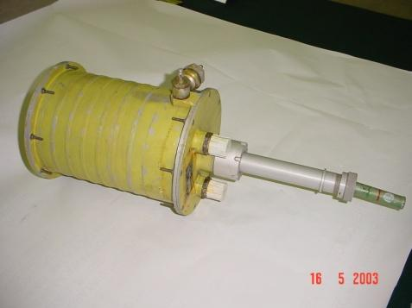

Hydraulic symbol of pressurized reservoir

Bootstrap hydraulic reservoir is a dual chamber pressure level. A bootstrap reservoir uses a differential area piston where high-pressure hydraulic fluid from the pump outlet is applied to the small area of the piston. This produces a low pressure on the reservoir side of the piston.

A major advantage of bootstrap reservoir is that it is a self-pressurizing tank and reservoir pressurization is maintained during aggressive flight maneuvers.

When the reservoir is at equilibrium P1A1 = P2A2. Since A1>> A2, P1<< P2. The pump nominal pump outlet pressure and the required level of reservoir fluid pressure set the differential piston areas. The two chambers of the bootstrap hydraulic reservoir have interconnected pistons. 210 Kgf/cm2 at high-pressure side of reservoir maintains 1.4 Kgf/cm2 at low-pressure side due to area ratio of both pistons. LP side of reservoir stores the oil supplies to the pump at 1.4 Kgf/cm2. Bootstrap reservoir is provided with a low-pressure relief valve at LP side and an oil level indicator.

Specifications of bootstrap hydraulic reservoir:

| **Reservoir Pressure** | **:** | **1.4 kgf/cm2** |
| --- | --- | --- |
| **System Pressure** | **:** | **210 kgf/cm2** |
| **Oil Capacity** | **:** | **3.88 liters** |
| **Swept Volume (Oil)** | **:** | **3.49 liters** |
| **Over Pressurisation** | **:** | **Relief Pressure 2.4 kgf/cm2**  **Reseat Pressure 1.85 kgf/cm2** |

| **Breakaway Pressure** | **:** | **17 kgf/cm2 (HP Side)**  **0.14 kgf/cm2 (LP side)** |
| --- | --- | --- |
| **Bore Dia.** | **:** | **162 mm** |
| **Stroke** | **:** | **169.5 mm** |
| **Low Pressure area** | **:** | **203.74 Cm2** |
| **High Pressure area** | **:** | **1.5 Cm2** |

5.2 Pump motor package:

In an actual hydraulic system, a pump converts mechanical power into fluid power. The intake of the pump is connected to a liquid source called reservoir or tank. A hydraulic pump is usually driven by an electric motor. Pumps are classified based on the fluid power required.







Hydraulic symbol of variable displacement unidirectional pump

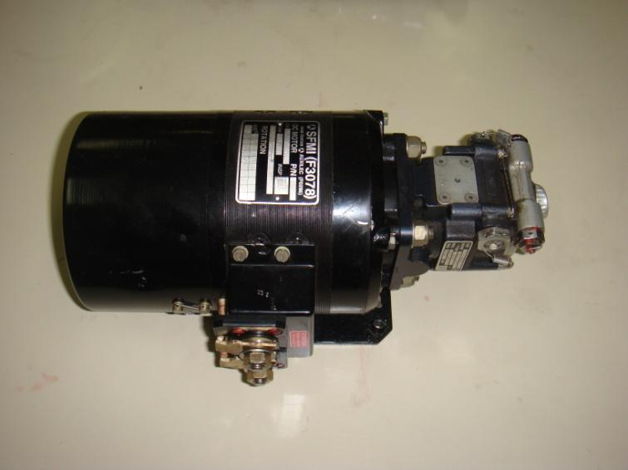

The pump motor package can be defined as a hydraulic power source, to deliver a rated flow at a rated pressure required by the hydraulic system. It is a variable displacement, pressure compensated, actual piston pump driven by a DC-Motor with a rated power. The displacement of pump is controlled by a built in pressure compensator. The pistons are held on a cam plate with hydrostatically balanced shoes. As the barrel rotates, the pistons reciprocate within their bores, taking in and discharging fluid through a stationary valving surface, at the port cap. The displaced volume from the pump is controlled by the inclination angle of the cam plate.

Specifications of pump motor package:

***PUMP***

| **Rated discharge pressure** | **:** | **207 + 3.5 kgf/cm2 2%** |
| --- | --- | --- |
| **Maximum full flow pressure** | **:** | **197 kgf/cm2 + 2%** |
| **Rated inlet pressure** | **:** | **1.4 kgf/cm2 + 2%** |
| **Rated delivery** | **:** | **(15.2 – 16.2) lpm** |
| **Rated speed** | **:** | **6750 rpm** |
| **Case drain leakage** | **:** | **0.9 lpm at back pressure of 3.0 kgf/cm2** |

***MOTOR***

| **Rated voltage** | **:** | **26 volt-DC 2%** |
| --- | --- | --- |
| **Rated current** | **:** | **315 amps 2%** |
| **Rated power** | **:** | **5.9 kw** |
| **Rated speed** | **:** | **6750 rpm** |
| **Rotation** | **:** | **Clockwise** |
|  |  |  |

NON – RETURN VALVE

A non-return valve (check valve) can be defined as valve, which allows flow of Hydrualic oil only in one direction. The direction of flow is clearly indicated on the component. The non-return valve is spring loaded poppet type. It consists of poppet valves, spring seat and spring. The spring-loaded poppet valve, which is machined from casting, allows the flow only in one direction. The spring tension is adjusted in such a manner that the operating pressure does not exceed valve-opening pressure.

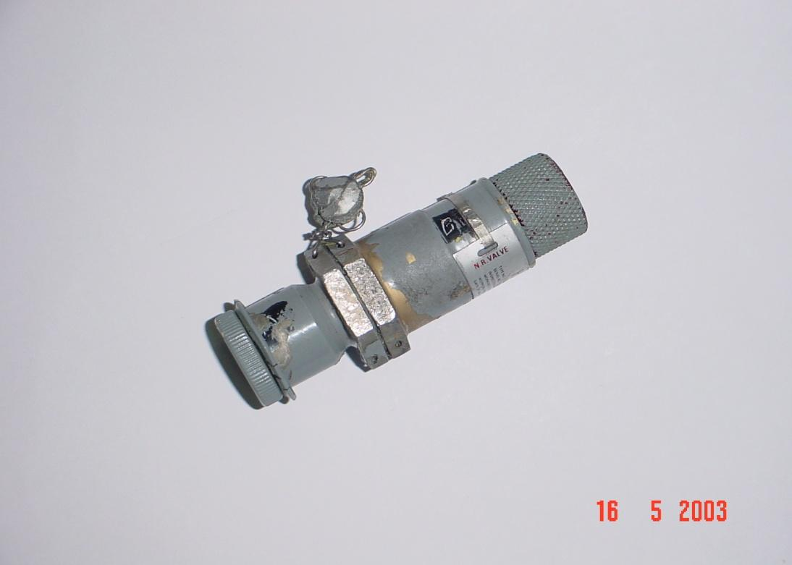

The reverse connection of the non-return valve in the hydraulic circuit will not allow the pressure to build up. It is used to safeguard the pump from the return flow when external hydraulic supply is connected.

Specifications of Non-Return Valve

* Rated working pressure = 210 Kgf/cm2
* Rated flow = 55lpm
* Pressure drop at rated flow = 1.85 kgf/cm2
* Valve opening pressure = 0.4 kgf/cm2

SERVO VALVE:

Used in closed loop control system applications, electrohydraulic servo valves have the highest dynamic response for intelligent hydraulics systems. With the appropriate system feedback and controller design, Rexroth hydraulic servo valves are unsurpassed in controlling pressure, flow, or position. Servo valves are appropriate for systems with one or more of the following characteristics: high load stiffness (static or dynamic); high accuracy and stability; precise positioning; fine control of velocity and acceleration control.

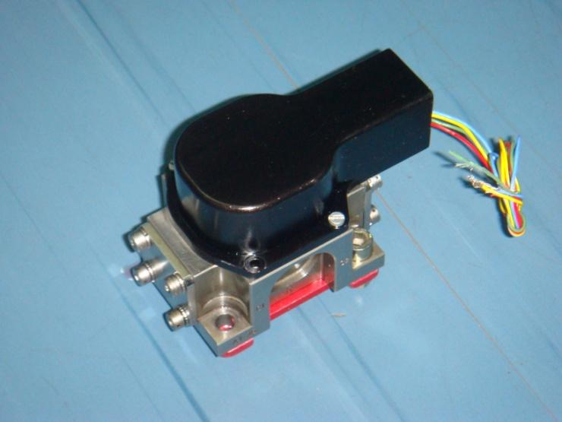

HIGH PRESSURE FILTER

High pressure filter is used to filter out the contamination in the system thereby improving system and performance and life. Filters are an important part of hydraulic systems. This filter is positioned between pump outlet and acutators.

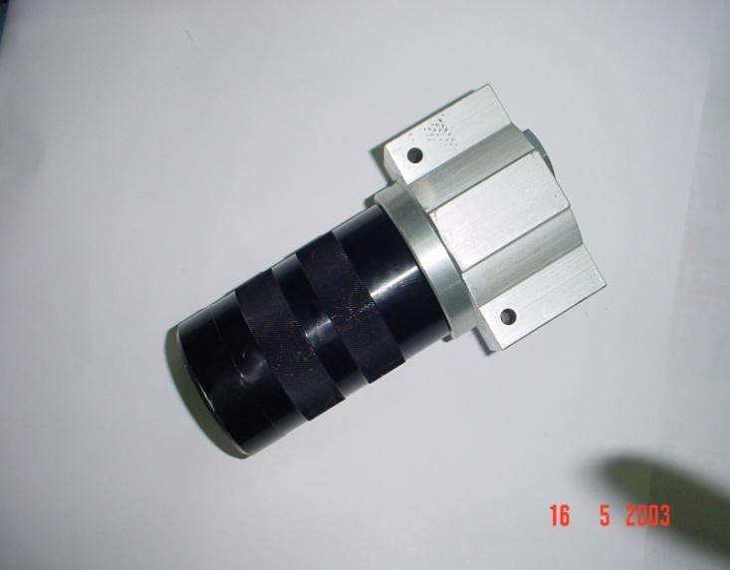

Specifications of High pressure filter:

* Working pressure = 210 Kgf/cm2
* Degree of filtration = 3µ absolute
* Flow rate = 36 lpm
* Temperature range = -200 to 1350 C
* Estimated pressure = 1.7 kgf/cm2

Drop across the assembly

PRESSURE RELIFE VALVE

When pressure in the system goes beyond specified value, Pressure Relief Valve gets operated and relieves extra pressure to return line. It is a normally closed valve connected between the pressure line and the fluid reservoir.

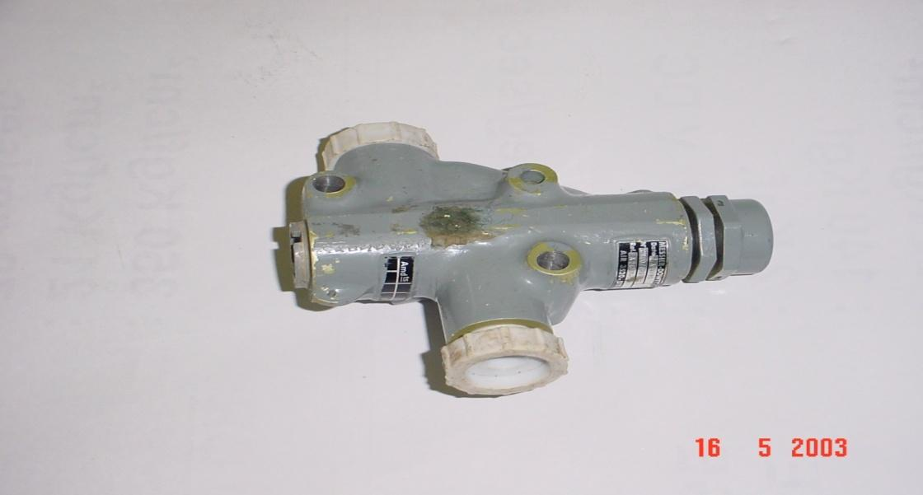

Its main purpose is to limit the pressure in a system to a prescribed maximum by diverting some or all of the pump output to the tanks, when the desired set pressure is reached. Relief valve can be defined as a safety device (safety valve) to prevent bursting of (or damage to) the system in the event the normal pressure regulation condition, relieve excessive pressure due to either thermal expansion of the fluid or overloaded forces of actuating unit.

Specifications of Pressure Relief Valve:

* Working pressure = 210 Kgf/cm2
* Relief pressure = 245+Kgf/cm2
* Flow rate = 20 lpm

QUICK CONNECT/DISCONNECT (QC/DC) COUPLINGS:

QC/DC are used to connect hoses. This coupling helps connection made quickly and easily. There is disclosed a quick connect/disconnect coupling for tubular elements such as hoses and the like, which uses a plurality of articulated jaws, with a retainer and a retainer cup. In this invention, each of the jaws has an axial groove extending from its inner edge, and the retainer sleeve has pins, which extend into the grooves of the jaws. The axial groove in each jaw has a stepped width, with a greater width at the inner edge of said jaw, thereby permitting a limited rotational movement of said ring between its rearward and forward positions. The retainer sleeve also as an inner annular groove adjacent to inner face, which receives a retainer, clip to secure the assembly.

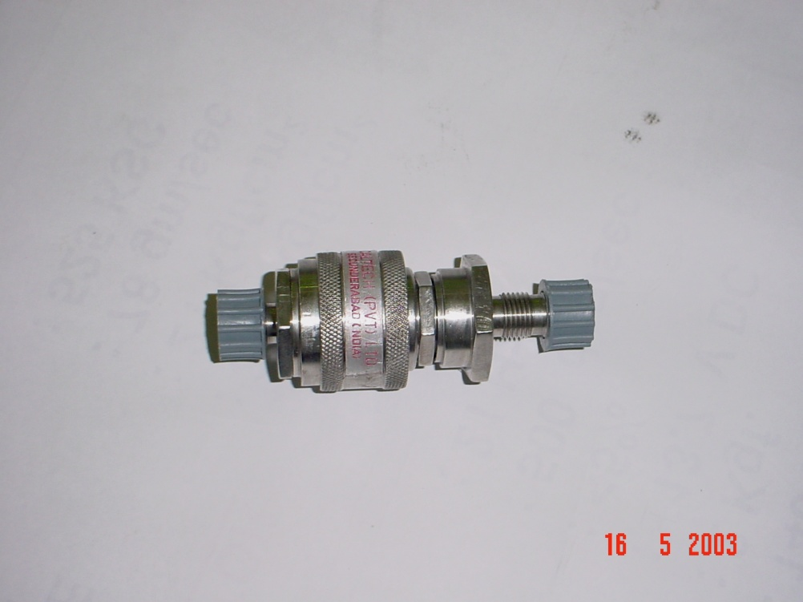

Specifications of QC/DC Coupling

* Working pressure = 210 Kgf/cm2
* Air inclusion = zero
* Spillage = nil

ACCUMULATOR

The hydraulic accumulator is a device used for storing the energy of a liquid in the form of pressure energy, which may be supplied for any sudden or intermittent requirement. Accumulator is a floating piston type having ultra pure dry N2 on one side and hydraulic oil on outer side. Accumulator supplies high-pressure hydraulic oil to the system when demanded.

It consists of a main body and a floating piston. On end of the accumulator is provided with gas charging connections and the other end is mounted with hydraulic connection. It works on Boyles principle, i.e. for constant temperature, the product of a pressure and volume of a gas is constant. The accumulator is charged with Nitrogen, when the pump is switched on the pressure of the pump will push the piston up leaving additional volume of fluid. The piston will take equilibrium position when pressure in the Nitrogen chamber is more, will push down the floating piston thereby expelling the hydraulic fluid from the accumulator to the system. Similarly, if the system pressure rises beyond the laid down limit, the piston is pushed further back increasing hydraulic chamber volume and thus reducing the pressure.

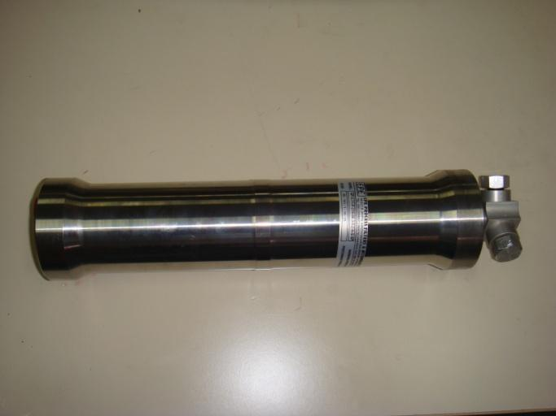

Specification of Accumulator

* Working pressure = 207kgf/cm2
* Nitrogen charging pressure = 80-120 kgf/cm2
* Swept volume = 700 cc
* Demand volume = 32 cc/discharge

CHARGING VALVE

Charging valve is used to change dry N2 to accumulator. It does not allow N2 to come out accumulator when charging is over.

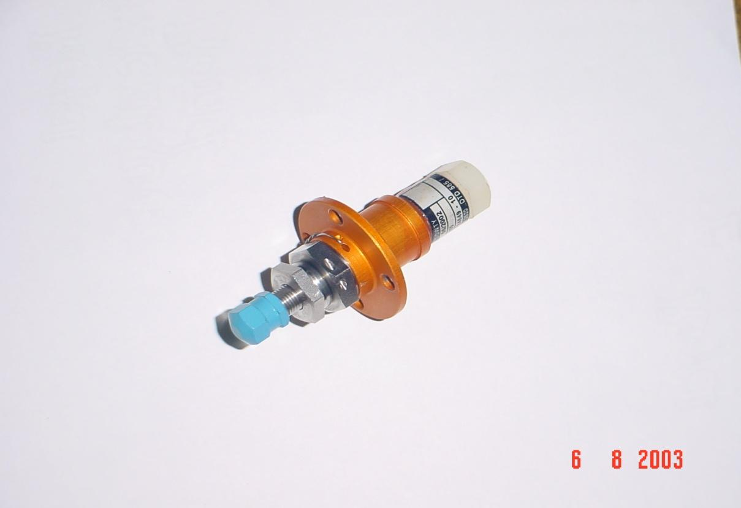

Specification of Charging valve

* Rate working pressure = 210kgf/cm2
* Rated charging pressure = 80-120 kgf/cm2
* Valve opening pressure = 0.5kgf/cm2

ACTUATOR

An actuator where in hydraulic energy is used to impart motion is called hydraulic actuator. Actuator produces physical changes such as linear and angular displacements. They also modulate the rate and power associated with these changes. A fluid power hydraulic cylinder is a linear actuator which is most useful and effective in converting fluid energy to an output force in linear direction for performing desired work. Hydraulic cylinders are broadly classified according to function performed and construction.

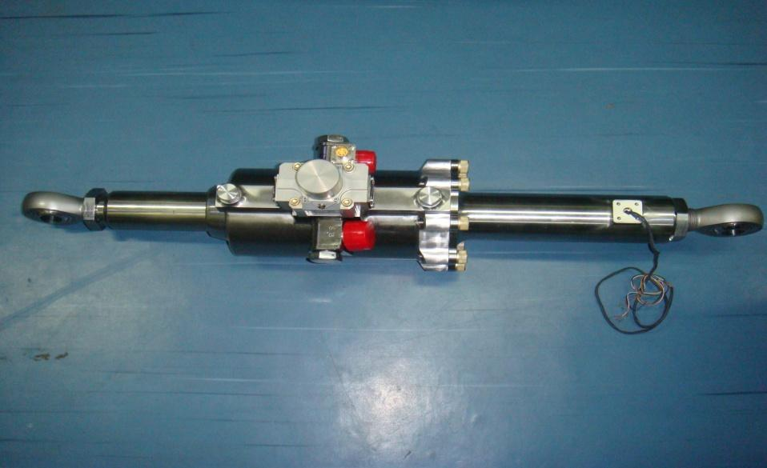

An electro-hydraulic servo jack is designed as an electrical input servo control valve coupled with hydraulic cylinder and feedback unit (potentiometer), capable of continuous control, either manually or automatically.

Actuator move the controlled element i.e. engine or control surface. Actuators function in the position control mode i.e. the position of the piston is proportional to the input current.

The actuator has three main components – a.) Servo valve, b.) Cylinder,

c.) Potentiometer.

The Actuator is double acting. The servo valve directs the flow to either side of piston depending upon the sign of input signal. In the cylinder, the high pressure oil pushes the piston rod out or in, depending on the direction of the flow. The two ends of the cylinder are provided with spherical bearings. The cylinder end is connected to the missile frame and the rod end is connected to the engine or control surface. The potentiometer is feedback element giving the information on the position of the piston rod. The potentiometer consists of a wire wound core and a wiper sliding an the winding. The winding is electrically energized (15 V) the wiper sliding on the winding gives the output voltage proportional to its distance from any end. The Outer body is connected firmly on the actuator body the wiper rod is connected to the moving piston through a lever. Electronic amplifier takes the feedback from potentiometer. The actuator has equal areas on either side.

Actuator consists of a Servo Jack and a Servo Valve. Servo Valve gives the required flow to move the linear actuator at specified velocity. Jack consists of piston& cylinder and a linear potentiometer to give position Feedback. Servo valve (flow control valve) plays a major role in electro-hydraulic actuation system. It consists of a torque motor stage and a hydraulic amplifier stage. Output flow rate is proportional to the input current.

Specifications of Actuator:

* Rated supply pressure = 210 Kgf/cm2
* System return pressure = 2.4 Kgf/cm2
* Rated flow (max.) = 12 lpm (at 70 Kgf/cm2 valve pressure drop)
* Rated input signal = + 10 mA
* Null leakage = 0.6 lpm
* Non-linearity = 10% (max.)
* Null bias = 500 mV (max.)
* Polarity = +ve signal piston retracts
* Servo valve resistance = 2000+10%Ω
* Frequency response at -900 phase shift = Not less than 12 Hz
* Length between the eye ends at null position = 290+1 mm

Low pressure filter

Hydraulic fluid passes through the low-pressure filter before entering to the reservoir in the feedback system. Low pressure filter filters out internally generated contaminations and prevents them from going into the system.

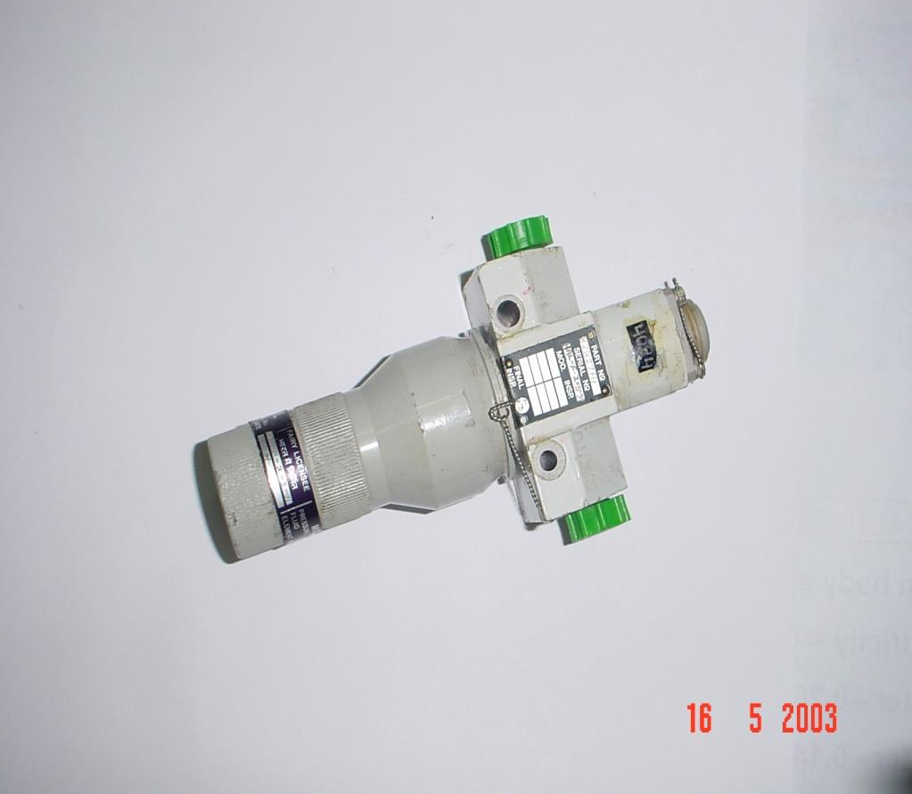

Specifications of Low pressure filter

* Working pressure = 14 Kgf/cm2
* Degree of filtration = 3µ absolute
* Flow rate = 9 lpm
* Temperature range = -500 to 1500 C
* Estimated pressure drop across the assembly = 1.7 Kgf/cm2

WORKING OF HYDRAULIC ACTUATION SYSTEM

A typical Aerospace vehicle hydraulic actuation system consists of thrust vector control (TVC) system and aerodynamic control (ADC) system.

TVC system consists of Boot strap hydraulic reservoir, a pressure relief valve, a non-return valve, a pump motor package, 4 actuators, 11 hose assemblies (both pressure and return) stainless steel pipe assemblies, hydraulic connectors and TVC linkage systems.

ADC system consists of 4 actuators, 10 hose assemblies, an accumulator, 2 QC/DC nipples, SS pipe assemblies, ADC linkage system, and a charging valve.

Hydraulic actuators achieve the gimballing of the engine in TVC and movement of the control surface in ADC. Each phase of the control scheme i.e. TVC and ADC is provided with a set of actuators. In the TVC phase, each engine is mounted with two actuators in mutually perpendicular directions (planes) for pitch and yaw.



In ADC phase, each of the four control surfaces is connected with an actuator. Total number of actuators in the vehicle is eight. The oil is stored in a bootstrap hydraulic reservoir, which supplies oil to the suction of the pump. The reservoir is self-pressurized piston type. It takes system pressure to develop a suction pressure. A variable delivery axial piston type pump driven by a DC compound motor, pumps the oil from reservoir at a rated system pressure. The electrical supply to the motor is taken from a battery. High-pressure fluid is pumped through a non-return valve and a high-pressure filter. A high-pressure filter relief valve is provided in the pressure line. The outlet of the relief valve is connected to the return line. Two accumulators are connected in line, up-stream to the actuators.

Accumulators supply demand flow over the pump flow and dampen the pressure surges. The accumulators are charged with ultra pure nitrogen. From each accumulator the supply is distributed to four actuators. Electro-hydraulic actuators convert fluid pressure into motion in response to a signal. Return oil from all the eight actuators are passed through two low-pressure filters and fed-back to the reservoir. Two quick connect couplings are provided in the pressure and return line for interfacing external rig.

PERFORMANCE EVALUATION OF HYDRAULIC ACTUATION SYSTEM COMPONENTS

TESTING OF ACTUATOR

The following tests are performed to ascertain the performance of all the units. All the units shall be subjected to the following tests prior to installation in the system.

Examination of the product:

The hydraulic assembly shall be inspected to determine the compliance to the given specification and to the applicable inspection reports/tags with respect to the inter-changeability, workmanship and installation. This is done by visual inspection for any external damages due to transportation and handling.

Operation and Leakage Test

1. Connect the actuator to the test rig with pressure line of actuator to preeure port return line to port.
2. Apply a pressure of 210 kgf/cm2 to the pressure port and cycle the actuator at 1 Hz + 9 volts for 60 cycles to 100 cycles.
3. Check for any external leakage from the end glands and servo valve interface.
4. Keep the piston at one end by giving positive signal of +9V.
5. At this pressure (210 kgf/cm2) hold for 3 minutes.
6. At the end of 3 minutes, check for external leakage.
7. Position the piston at the other end by changing the polarity of signal to -9V and repeat the procedure. At the end of 3 minutes, again check for external leakage.

Maximum Displacement Test

The piston of the jack should have a capability to move either side of the neutral point to the extent as prescribed. The displacement is measured in terms of the electrical output from the potentiometer.

1. Switch oin the servo control unit to the test setup.
2. Vin is set to +9V.
3. Hydraulic pressure to the actuator is slowly increased to 70 kgf/cm2 and measure Vfb (feedback voltage)
4. Withdraw the hydraulic pressure and set Vin to -9V
5. Again apply hydraulic pressure to the actuator and slowly increase to 70 kgf/cm2 and measure Vfb.
6. Switch off the hydraulic supply and servo control unit of the jack.
7. Check whether the displacement of the actuator is equal on either sides and proportional to the input value.

NOTE: During this test, always the signal is given before giving the hydraulic pressure and Vfb sign shall be negative to the Vin.

Null Off Set Test and Leakage Measurement Test:

Keeping the electrical input zero volt supply, the feedback output shall remain within a specific limit when the hydraulics is energized. This limit is called as null offset.

1. The jack is connected to the test setup and the servo control valve and hydraulic supply to the jack is switched on.
2. Vin is set to 0V by shorting Vin in return.
3. Hydraulic pressure to the jack is slowly increased to 210KSC and measure Vfb and leakage flow through return line in a jar.
4. Switch off the hydraulic supply and servo control unit to the jack at the end of 2 minutes.
5. The measured values of Vfb and leakage flow are noted down.

Threshold Test:

Threshold can be defined as minimum input signal with which the piston starts moving.

1. The jack is connected to the test setup.
2. Connect Vin to the generator output of the FRA. Set the generator initially to a square wave of amplitude 0V and 0.1 Hz frequency.
3. Switch on the servo control unit and hydraulic supply to the jack.
4. Hydraulic pressure to the jack is slowly increased to 210 kgf/cm2 and start the generator.
5. Measure Vfb and increase generator output amplitude in steps of 0.02V till the Vfb changes at least by 0.02V from its initial value i.e., jack moves.
6. The value of the input at which Vfb changes by 0.02V is noted down n is known as threshold frequency.

Gain and Linearity Test:

Gain is defined as the ratio equal to (Vfb/Vin). linearity is defined as deviation from the nominal value of the gain.

1. The jack is connected to the test setup.
2. Switch on servo control unit.
3. Set FRA generator to a sine wave signal of 6.35V rms at 0.02 Hz.
4. Connect the Vin and Vfb to x-y recorder.
5. Switch on hydraulic supply and set pressure to 210 kgf/cm2.
6. Switch on the generator and at the end of one cycle, switch off the hydraulic supply and SCU.
7. Check whether the x-y plot recorded remains within the band indicated on the recorded for each type of jack.

Frequency Response Test:

It is defined as the behavior of the output response of the jack with respect to a given input. This is specified as a quadrate frequency at -900 phase lag for a sinusoidal input.

1. The jack is connected to the test setup.
2. Connect Vin to channel 1 of FRA and Vfb to channel 2 to FRA.
3. Set the FRA to the following parameters:

Frequency: 0.5Hz

Amplitude: 1.0V

Bias: Zero

Waveform: Sine

Integration time: 1 sec

Minimum frequency: 0.5Hz

Maximum frequency: 20Hz

Linear: 0.5Hz

Source: ch2/ch1

Co-ordinates: log r and θ

1. Switch on the SCU and hydraulic supply. Increase the pressure to 210 kgf/cm2.
2. Initiate the sweep signal from FRA.
3. Stop the generator of the FRS after the completion of the sweep signal.
4. Switch off the hydraulics supply and SCU.
5. Gain and phase values stored in the FRA are noted at each frequency and frequency Vs phase shift and gain plot is plotted.
6. Frequency at -900 phase shift shall be noted. Also frequencies at different phase shifts are tabulated.

Testing of Pump Motor:

All the units shall be subjected to the following tests prior to installation in the system.

Examination of the Product:

The hydraulic assembly shall be inspected to determine the compliance to this specification and to the applicable inspection reports/tags with respect to the inter-changeability, workman-ship and installation. This is done by the visual inspection for any external damages due to the transportation and handling.

Functional Test:

This test is carried out as per the steps below:

1. Connect the pump-motor package as per the test setup.
2. Set the required voltage 26V DC using a rectifier or any other DC power supply.
3. Using the low pressure power source, supply a pressure of 1.4 + 0.1kgf/cm2 at the suction port by opening a valve ‘A’ and switch on the motor with valve ‘B’ closed.
4. Record the delivery pressure PT2, suction pressure PT1, and motor current after 30 secs. (Preset the case drain relief valve to 3 kgf/cm2).
5. Open valve C and measure the case drain leakage using measuring jar and stop watch.
6. Switch off the motor, open valve A, B and close valve C.
7. Switch on the motor and record PT1 & PT2 and note the flow rate as known from the calibrated orifice.
8. The values recorded should be within the tolerance specified in the specifications.

Testing of Filter Assembly:

All the units shall be subjected to the following tests prior to installation in the system.

Examination of the Product:

The hydraulic assembly shall be inspected to determine the compliance to this specification and to the applicable inspection reports/tags with respect to the inter-changeability, workman-ship and installation. This is done by the visual inspection for any external damages due to the transportation and handling.

Leak Test:

Filter assemblies shall withstand a pressure of 1.4 kgf/cm2 and 210 kgf/cm2 for Low pressure and High Pressure filters respectively without the evidence of permanent deformation, malfunction or external leakage. The filter assembly shall be filled with test fluid and maintained at room temperature. A pressure equal to the operating pressure shall then be applied and held for 3 minutes.

Contamination Test:

1. Collect the oil at the inlet and outlet of the filter separately in the sampling bottle.
2. Analyze the oil for the contamination using a particle counter.
3. Contamination of the oil at the outlet port shall be less than or equal to the contamination of the oil at the inlet port.

Testing of Accumulator:

All the units shall be subjected to the following tests prior to installation in the system.

Examination of the Product:

The hydraulic assembly shall be inspected to determine the compliance to this specification and to the applicable inspection reports/tags with respect to the inter-changeability, workman-ship and installation. This is done by the visual inspection for any external damages due to the transportation and handling.

Leak Test:

1. Keep the fluid port to atmosphere, immersed in the tank with fluid.
2. Pressurize the gas side of the accumulator to 14 kgf/cm2 (use air or N2) for 3 minutes.
3. Check for external leakage.
4. Internal leakage shall be less than 0.1 kgf/cm2.
5. Repeat the above steps with a gas pressure of 80-120 kgf/cm2 for 3 minutes.
6. Mount the accumulator in vertical position with fluid port for a period of 3 minutes.
7. Apply of pressure of 207 +3.5 kgf/cm2 to the fluid port for a period of 3 minutes.
8. Check for external leakage and internal leakage should not exceed the prescribed value.

Cycling:

The unit is cycled (exercised) ten times before conducting any test. This is to ensure free movement of the floating piston. The steps involved are explained below:

1. The unit is connected with N2 (dry air) at a pressure of 80 – 120 kgf/cm2 and mounted on the test stand.
2. Fluid port is connected to the variable pressure source (hydraulic test rig).
3. Fluid pressure is varied from 0 to 207 kgf/cm2, thus exercising the piston for ten times.
4. Check for smooth rise and drop in pressure during this operation.

10. CONTAMINATION OF HYDRAULIC SYSTEM

The experience of hydraulic system designers and maintenance supervisors have shown that over 50% of the downtime of hydraulic operated machinery is caused by dirt in the hydraulic fluid.

Excessive fluid velocities add dirt to a system by erosion of pipe and component surfaces. Air entering the pump contains dirt and water vapour which causes the formation of rust on reservoir walls. An additional source of dirt is the dirt which is continuously added to a system through maintenance practices. Every time a line is cracked to service a component, the system becomes more contaminated. It also not uncommon for maintenance men to dump dirty fluid into a machine’s reservoir by accident or due to lack of education.

SOURCES OF CONTAMINATION

Contamination may be classified as:

1. Built-in metal chips, welding scales, lapping compound, sand from casting or debris reduced during the manufacturing process.
2. System generated – wear products generated inside the mating components may be categorized here.
3. Maintenance generated – contaminants generated by opening and closing a system and exposed often to dirty maintenance environments are examples of maintenance oriented contaminants. The new fluid added to the tank during filling-up operation is also another source of contamination.

CONTAMINANTS DURING ASSEMBLY STAGE

1. Pipe scale – from pipes not cleaned before assembly.
2. Corrosion or rust – from ferrous metal components stored in unfavorable conditions.
3. Sand – residue foundry sand on castings, e.g. valve blocks.
4. Lints or fabric threads – from clothes used for plugging or cleaning components.
5. Swarf – produced by incorrect assembly tools or technique.
6. Adhesive particles – from surplus adhesive or joining compounds used on gaskets or static seals (e.g. thread sealants)

It is most important that care should be taken to ensure correct and clean assembly before a system is put into operation.

CONTAMINATION DURING SERVICE

Once in service, likely sources of further contaminations are produced, e.g. metallic particles besides being harmful because of their abrasive and blocking character, finely divided metal can act as a catalyst promoting early breakdown of the fluid. Metallic particles are very likely to be developed in a new system, due to initial pump wear. After a suitable ‘running in’ period sets in, the wear rate of pumps and other mating parts gets reduced due to the lubricating property of the fluid. Paint flake caused by the old paint on the inside of the tank or paints which are not compatible with fluid are also quite harmful.

As the machine continues to operate, moving parts naturally begin to wear and generate dirt. Therefore every internal moving part in the system can be considered a source of future contamination, especially during the machine’s “breaking in” or “running in” period. Component housing continuously experience hydraulics and mechanical shocks due to constant flexing normal stresses and pressures, these actions cause metal and casting sand to break loose and enter the fluid stream.

Some other contaminations are:

1. Acidic by-products – This is mostly caused by the process of oil oxidation. Normally, this is soluble but leads to corrosion problems.
2. Sludge – This is also caused by oxidation and fluid-breakdown.
3. Elastomeric particles – This is generated from seal wear.
4. Airborne solids – They are induced through the tank. Joints, piston surfaces, etc. when leakage of oil takes place.

DAMAGE DUE TO SOLID CONTAMINANTS

It has been explained earlier that a lot of solid particles find their way into a hydraulic system. These particles are generally produced due to high mechanical stresses to which the system components are subjected. As during the operation of the machine, these particles are circulates unhindered throughout the system. They produce more solid particles and a chain reaction follows aggravating the situation and accelerating the failure of the system. Solid particles in a system may cause:

1. Blockage of valve openings.
2. Jamming of pistons and spools.
3. Uncontrolled and increased leakage.
4. Changes in control characteristics.
5. Ultimately component or system failure.

The amount of wear and tear of hydraulic components due to solid contaminants depends on the :

1. Material of the solid particles.
2. Size of the solid particles.
3. Nature of working clearance between mating parts of the components.
4. Ratio of particle size to gap between the mating parts of the components.
5. Shape of solid particles.
6. The oil flow velocity.
7. The working pressure of fluid.

It is noted that hard and sharp particles may cause deep scratches, erosion, etc. and hence are more dangerous than soft and spherical particles. Soft and gelatinous particles may cause undesirable blockages lubricating passages which are generally very narrow and finely finished. The nature and severity of damage that solid particles can cause depends on the type of the materials and their characteristics.

EFFECT OF DIRT ON INDIVIDUAL HYDRAULIC COMPONENTS

It is accepted that 75% of the problems of a hydraulic system are dirt-related. Due to the presence of the particle contaminants, the fluid power component may have the following problems as given below:

1. Cylinders – Excessive wear of cylinder rod, packing and seals.
2. Hydraulic valves – Small and intricate orifices get plugged, spools and housing land wears may cause excessive leakage, accumulated dirt makes pressure erratic.
3. Pumps – Wear and tear of pistons and piston sleeves may increase, vane slots may wear out with rapidity.

RESULT OF CONTAMINATIONS

The wear debris may act as a catalyst to accelerate the process of oxidation and breakdown the molecular structure causing gummy residue and varnish which are quite injurious to the system. This may ultimately lead to the following:

1. Attract additives and may change the composition of the oil. Attract additives and may change the composition of the oil

The fluid life gets shortened necessitating premature replacement of the fluid.

1. Lower down maximum operating temperature.

Hydraulic system malfunctions due to dirt may result in:

1. Damage to equipment.
2. Safety hazards.
3. Scrapping of parts due to poor finish.
4. Insufficient pressure and increased downtime.
5. Unnecessary maintenance and production cost.
6. Higher oil cost with increased disposal problem.

ANALYSIS OF THE HYDRAULIC ACTUATOR:

The main objective of this project is to do structural analysis of the important parts of the actuator i.e., piston, body, eye-end. This structural analysis will help us to verify the strength of material, buckling, factor of safety of the actuator.

The three important parts of the actuator are:

* Piston
* Eye end
* Body

The analysis process is carried in the Ansys-Workbench. These three parts are subjected to the structural analysis separately in the Ansys Workbench.

The Structural Analysis of the Piston part:

CODE FOR PISTON:

Install the Ansys 12.0 pattern in to the system

Open>Ansys Workbench

Open>Static Structural analysis 

Geometry> new geometry > select desire length of unit m

File>Import external geometry file> file name: piston > open >o.k.

files of type: All geometry

Details of import file: Import -import 1

Source -piston

Base plane-XY plane

Operation – Added material

Process of Solid bodies- Yes

Process of Solid surfaces -Yes

Process line bodies – Yes > Generate

Open > Ansys Workbench > Model > Edit

Model > Co-ordinate system > Global co-ordinate system > o.k.

Mesh> Generate mesh > o.k.

Static Structural > Analysis setting > Insert > Pressure 

Definition: magnitude >P>3.15

Define> normal to plane

Scope: Geometry >apply (selected part)

Analysis setting > Insert > Force 

Definition: magnitude >P>10000

Define> vector

Scope: Geometry >apply (selected part)

Analysis setting > Insert > Fixed support

Scope: Geometry >apply (selected part)

Solution > Total deformation >o.k.

Stress> maximum principal stress> Result -P > equivalent stress> Result- P

Strain > maximum principal strain > Result -P > equivalent stress> Result- P

Solution

Solve

Solution information > total deformation (select any option of stress, strain, total deformation) > Extract all results> o.k.

Main menu > Files > send to > desk top > o.k.

The Structural Analysis of the Eye end part:

CODE FOR EYE END:

Install the Ansys 12.0 pattern in to the system

Open>Ansys Workbench

Open>Static Structural analysis 

Geometry> new geometry > select desire length of unit m

File>Import external geometry file> file name: eye end > open >o.k

files of type: All geometry

Details of import file: Import -import 1

Source -piston

Base plane-XY plane

Operation – Added material

Process of Solid bodies- Yes

Process of Solid surfaces -Yes

Process line bodies – Yes > Generate

Open > Ansys Workbench > Model > Edit

Model > Co-ordinate system > Global co-ordinate system > o.k.

Mesh> Generate mesh > o.k.

Static Structural > Analysis setting > Insert > Pressure 

Definition: magnitude >P>3.15

Define> normal to plane

Scope: Geometry >apply (selected part)

Analysis setting > Insert > Force 

Definition: magnitude >P>10000

Define> vector

Scope: Geometry >apply (selected part)

Analysis setting > Insert > Fixed support

Scope: Geometry >apply (selected part)

Solution > Total deformation >o.k.

Stress> maximum principal stress> Result -P > equivalent stress> Result- P

Strain > maximum principal strain > Result -P > equivalent stress> Result- P

Solution

Solve

Solution information > total deformation (select any option of stress, strain, total deformation) > Extract all results> o.k.

Main menu > Files > send to > desk top > o.k.

The Structural Analysis of the Body:

CODE FOR BODY:

Install the Ansys 12.0 pattern in to the system

Open>Ansys Workbench

Open>Static Structural analysis 

Geometry> new geometry select desire length of unit m

File>Import external geometry file> file name: body > open

files of type: All geometry

Details of import file: Import -import 1

Source -piston

Base plane-XY plane

Operation – Added material

Process of Solid bodies- Yes

Process of Solid surfaces -Yes

Process line bodies – Yes > Generate

Open > Ansys Workbench > Model > Edit

Model > Co-ordinate system > Global co-ordinate system > o.k.

Mesh> Generate mesh > o.k.

Static Structural > Analysis setting > Insert > Pressure 

Definition: magnitude >P>3.15

Define> normal to plane

Scope: Geometry >apply (selected part)

Analysis setting > Insert > Force 

Definition: magnitude >P>10000

Define> vector

Scope: Geometry >apply (selected part)

Analysis setting > Insert > Fixed support

Scope: Geometry >apply (selected part)

Solution > Total deformation >o.k.

Stress> maximum principal stress> Result -P > equivalent stress> Result- P

Strain > maximum principal strain > Result -P > equivalent stress> Result- P

Solution

Solve

Solution information > total deformation (select any option of stress, strain, total deformation) > Extract all results> o.k.

Main menu > Files > send to > desk top > o.k.

Static Structural Analysis results in Ansys Workbench:



# Project

Results for Body: 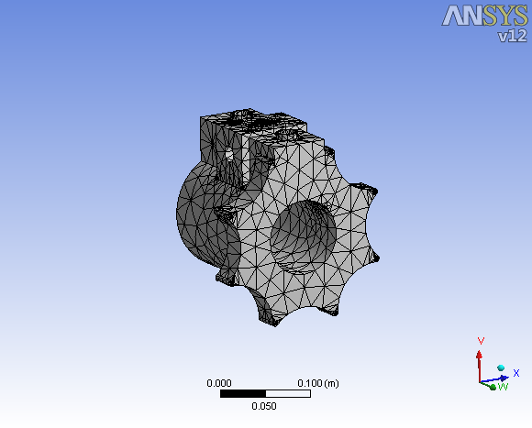

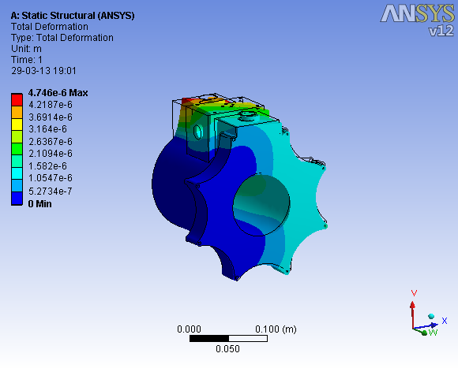

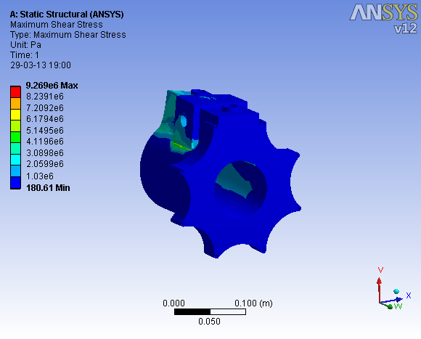

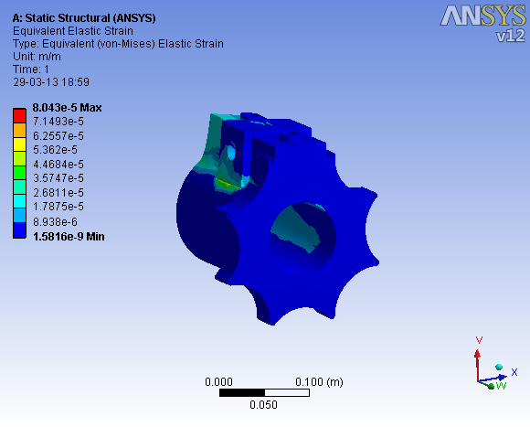

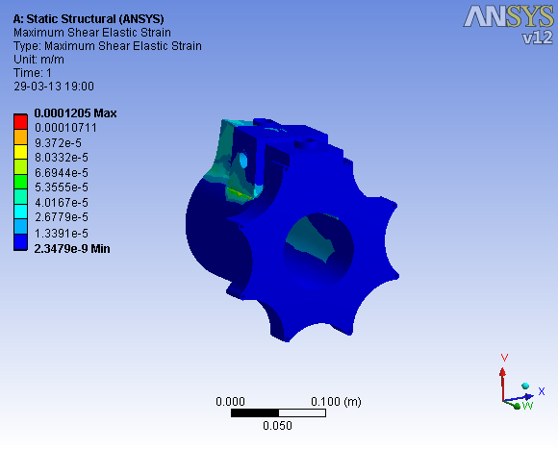

Results of Piston:

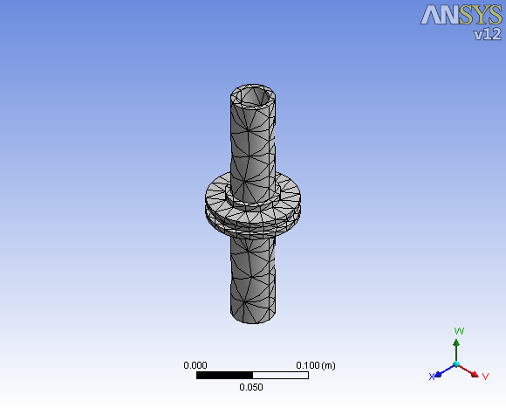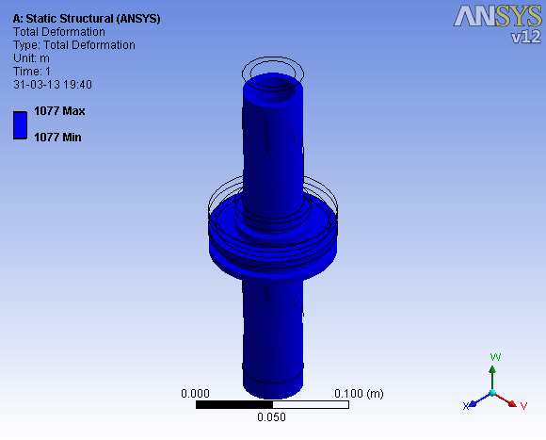

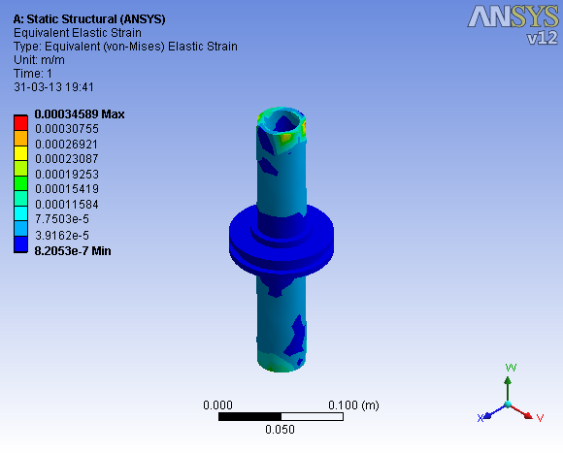

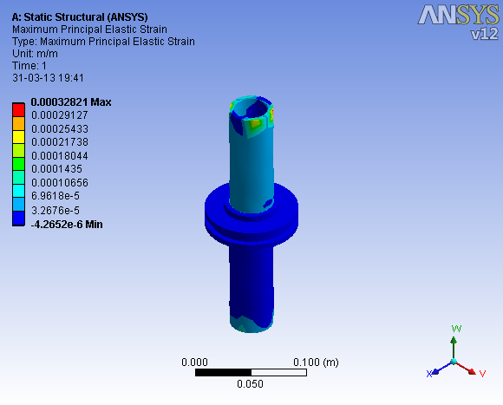

Results of Eye end:

